Function Arguments and return statement
There are four types of arguments that we can provide in a function:
- Default Arguments
- Keyword Arguments
- Variable length Arguments
- Required Arguments
Default arguments:
We can provide a default value while creating a function. This way the function assumes a default value even if a value is not provided in the function call for that argument.
Example:
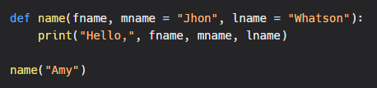
Output:
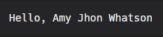
Keyword arguments:
We can provide arguments with key = value, this way the interpreter recognizes the arguments by the parameter name. Hence, the the order in which the arguments are passed does not matter.
Example:
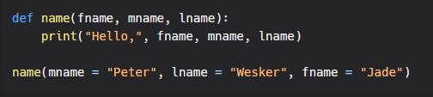
Output:
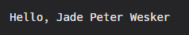
Required arguments:
In case we don’t pass the arguments with a key = value syntax, then it is necessary to pass the arguments in the correct positional order and the number of arguments passed should match with actual function definition.
Example 1: when number of arguments passed does not match to the actual function definition.
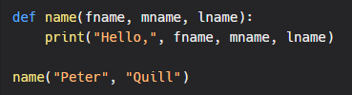
Output:
Example 2: when number of arguments passed matches to the actual function definition.
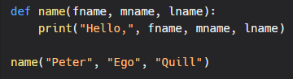
Output:
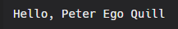
Variable-length arguments:
Sometimes we may need to pass more arguments than those defined in the actual function. This can be done using variable-length arguments.
There are two ways to achieve this:
Arbitrary Arguments:
While creating a function, pass a * before the parameter name while defining the function. The function accesses the arguments by processing them in the form of tuple.
Example:
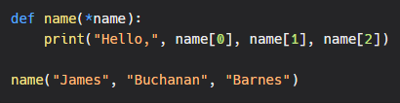
Output:
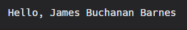
Keyword Arbitrary Arguments:
While creating a function, pass a * before the parameter name while defining the function. The function accesses the arguments by processing them in the form of dictionary.
Example:
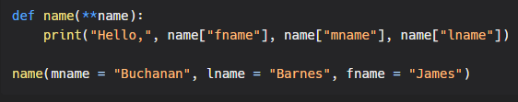
Output:
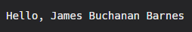
return Statement
The return statement is used to return the value of the expression back to the calling function.
Example:
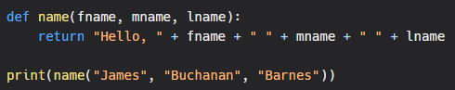
Output:
